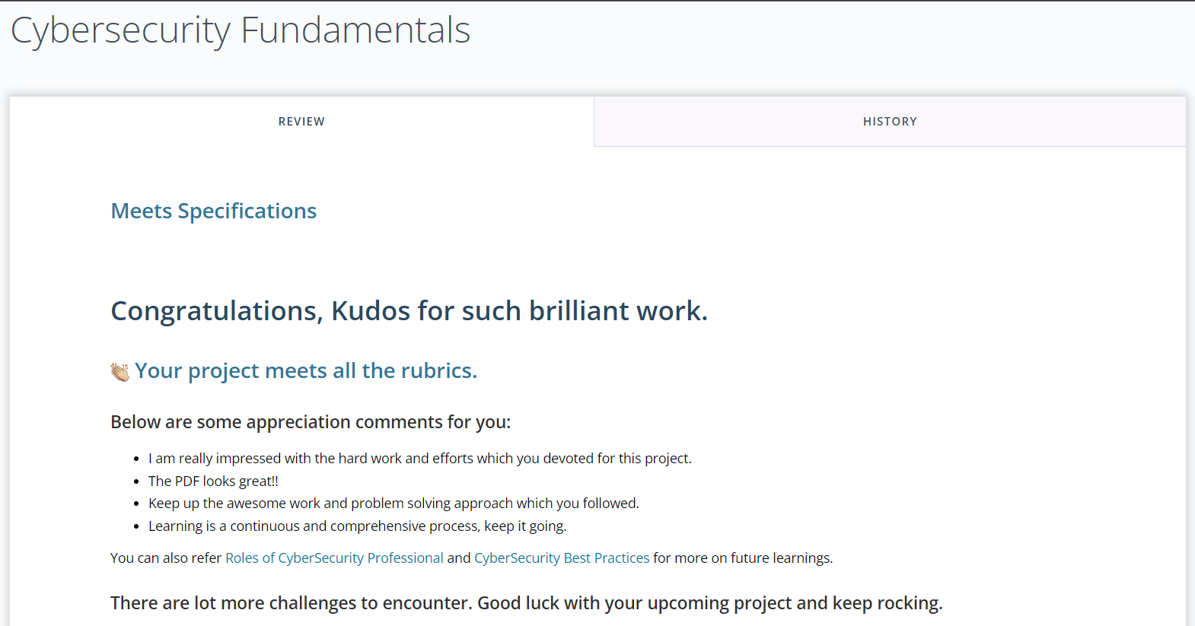

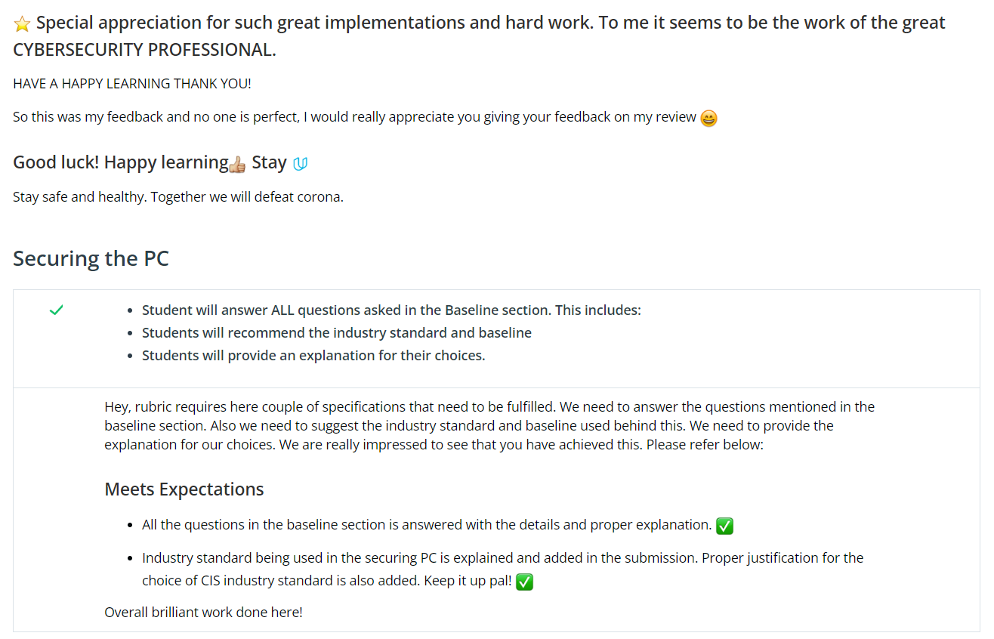

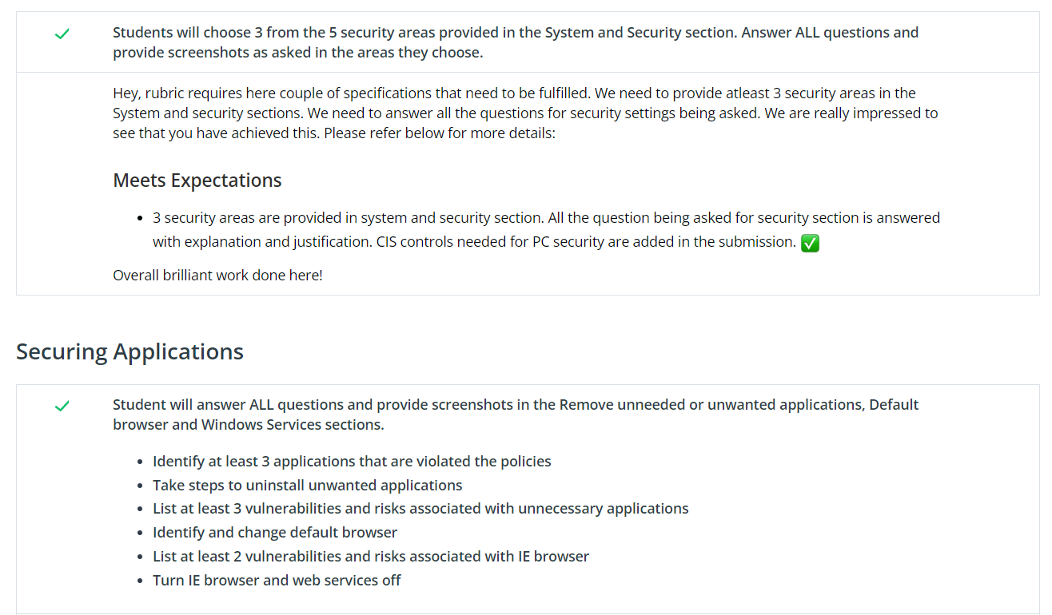

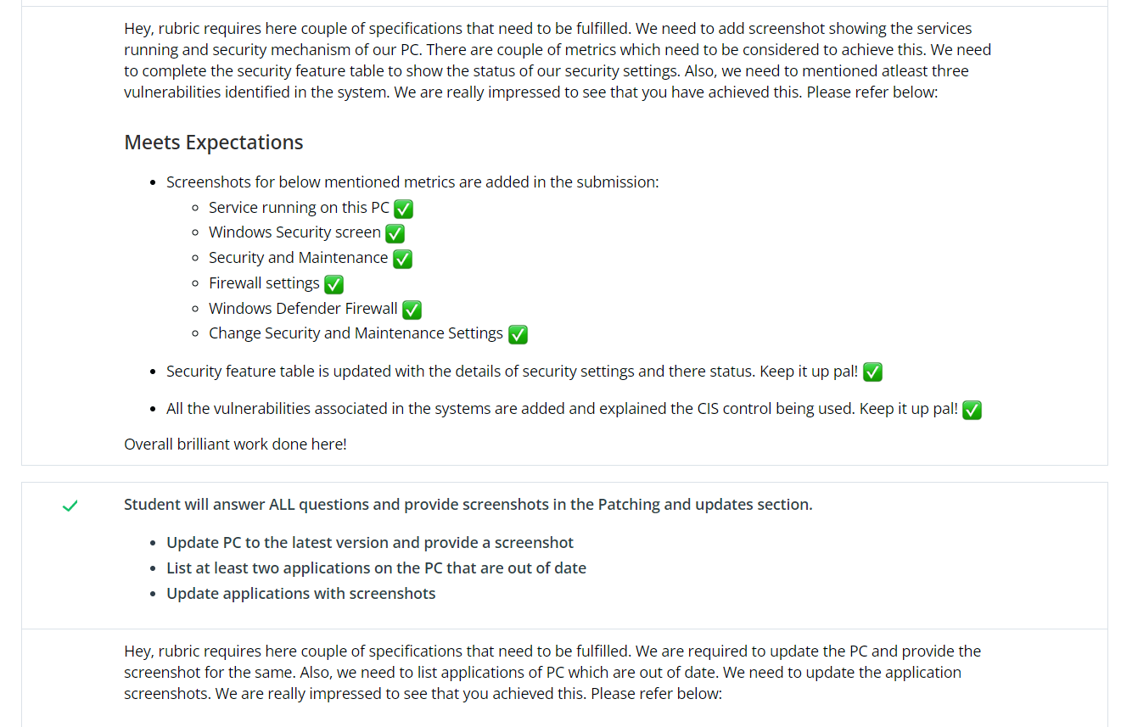

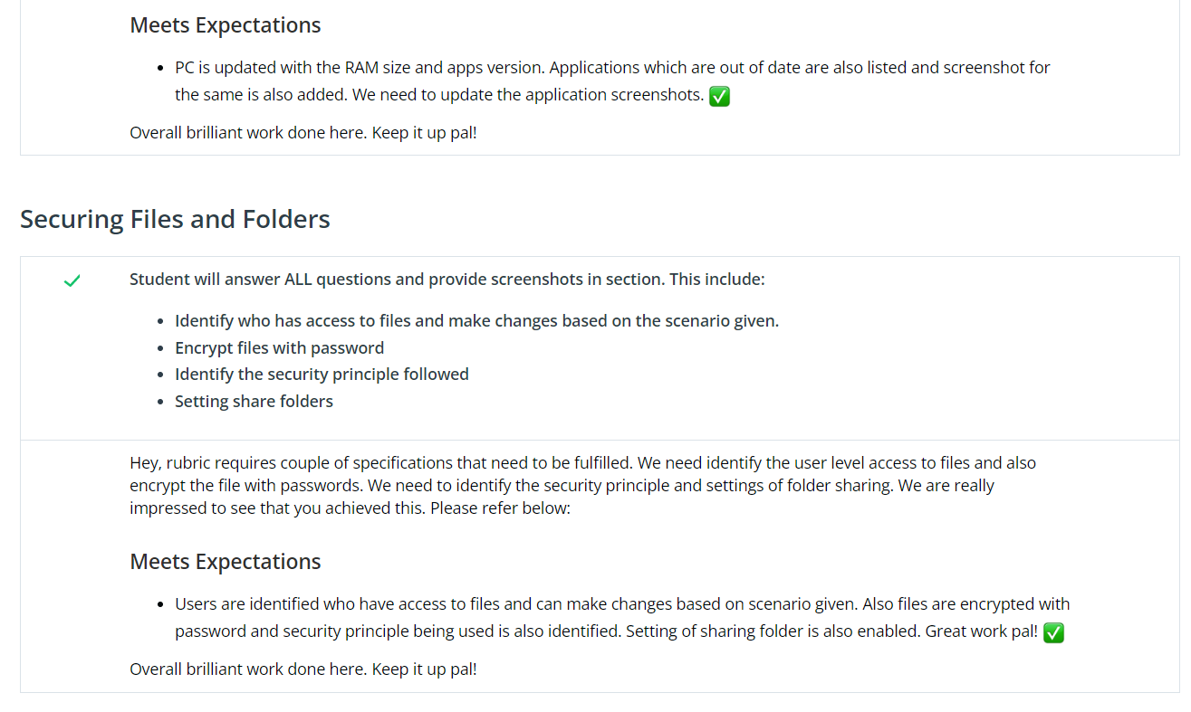

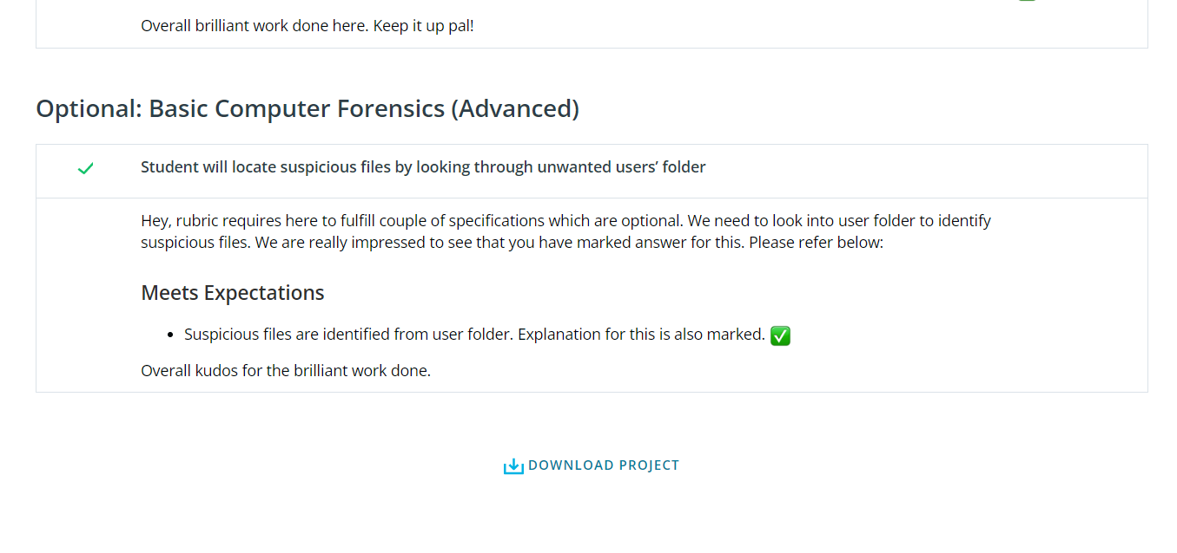

<https://www.cisecurity.org/cybersecurity-best-practices/>

<https://www.springboard.com/library/cybersecurity/job-responsibilities/>

<https://api.udacity.com/api/review/v1/submissions/3986918/archive>

[https://review.udacity.com/#!/reviews/3986918](https://review.udacity.com/%23!/reviews/3986918)